

CITY OF HEMET

CITIZEN PARTICIPATION PLAN

City Council Approved November 10, 2020

Finance Department
LORENA ROCHA
FINANCE DIRECTOR
445 E. FLORIDA AVENUE
HEMET, CALIFORNIA 92543
(951)765-2331

Table of Contents

Introduction | 1
Encouraging Public Participation | 1
Public Access to Information | 2
Consolidated Plan Process | 3
City of Hemet Annual Action Plan Process | 4
Public Hearings | 5
Public Hearings During a Disaster | 5
Public Notice | 6
Public Notice During a Disaster | 6
Written Public Comment | 7
Public Comment During a Disaster | 7
Amendments | 8
Technical Assistance | 8
Anti-displacement | 8-9
Complaint Procedures | 9
Collaborative Agencies | 10
Definitions | 10
City of Hemet Census Tract Map | 11

INTRODUCTION
The City of Hemet, as an annual recipient of U.S. Department of Housing and Urban Development (HUD) funding, is required to have and follow a detailed Citizen Participation Plan containing the City’s policies and procedures for public involvement in:
- the development of the Five-Year Consolidated Plan – identification of needs and priorities for use of HUD funding;
- development of the Annual Action Plan – itemized proposed use of annual allocation of HUD funding;
- review of the Consolidated Annual Performance Evaluation Report (CAPER) – detailed evaluation of actual expenditure of annual allocation of HUD funding; and
- substantial amendments to the Citizen Participation Plan, Consolidated Plan, Annual Action Plan, or the CAPER.

ENCOURAGING PUBLIC PARTICIPATION
The Code of Federal Regulations-Title 24-Part 91-Subpart B, requires that the City of Hemet’s Citizen Participation Plan both provide for and encourage public participation. The primary purpose of the programs covered by this Citizen Participation Plan is to improve communities by providing decent housing, a suitable living environment, and growing economic opportunities—all principally for low and moderate income people. Therefore, the City will publish notices of public meetings, comment periods and public hearings in both the Press Enterprise and Spanish language, La Prensa newspapers, and on the City website www.hemetca.gov to encourage involvement by all of its residents, particularly, low- and moderate- income residents, residents of blighted neighborhoods, minorities, non-English speaking persons and persons with disabilities who may benefit from the use of HUD funded activities. In addition the City will consult with the Housing Authority of Riverside County to encourage the participation of residents of assisted housing developments within the City of Hemet. Opportunities for public participation may also be publicized through direct notification (mail, e-mail or flyers) of groups and individuals who have expressed an interest or whom the City identifies as having a greater potential interest, such as disabled persons, minorities, seniors, youth, etc. The City will provide opportunities for public involvement at all stages of the process, including:
- Identifying needs;
- Prioritizing identified needs; and
- Overseeing the way in which programs are carried out.

PUBLIC ACCESS TO INFORMATION
Residents of Hemet, public agencies and other interested parties will be provided with reasonable and timely access to local meetings, information, and records relating to the proposed, actual, and past use of funds covered by this Citizen Participation Plan.

Standard documents will be available for public review at the Hemet City of Hemet Hall, 445 East Florida Avenue, Hemet, California, 92543 and the City’s website www.hemetca.gov. All standard documents are maintained and accessible for a period of five (5) years as required by Consolidated Plan Regulations [24 CFR 91.105(h)]. These documents will be provided, when requested, in an accessible format to persons with disabilities and non-English speakers. Standard documents include:
- The Citizen Participation Plan
- The Five-Year Consolidated Plan
- The Annual Action Plan
- The Consolidated Annual Performance and Evaluation Report
- Substantial Amendments to any of the listed documents

CONSOLIDATED PLAN PROCESS

The purpose of HUD funding is to carry out a wide range of community development activities directed toward revitalizing neighborhoods, economic development and providing community facilities and services, with maximum feasible priority given to activities which benefit low and moderate income persons. The City is responsible for developing its own programs and funding priorities within HUD requirements, through the Consolidated Plan Process. In order to develop and implement an effective plan the City must actively engage residents, public agencies and other interested parties at all stages of the process.

In general, this process includes:
- Identification of housing and community development needs
- Preparation of the Five-Year Consolidated Plan
- Preparation of the Annual Action Plan
- Public comment and hearing of the proposed plan
- Formal approval by the Hemet City Council of the proposed plan
- When necessary, preparation of a substantial amendment to revise priorities, activities or funding
- Preparation of the CAPER

The City will notice and hold a public hearing at the beginning of the Consolidated Plan process, typically in September, to obtain residents’ views about the City’s diverse housing and community development needs and what priority those needs have, prior to preparation of the proposed Five- Year Consolidated Plan or the Annual Action Plan. At the housing and community development needs public hearing, City Council will direct staff to establish a process for evaluating funding requests for the upcoming program year. Previous processes include City Council ad hoc committee, citizen advisory panel, and staff advisory panel.

City staff will facilitate the funding request and evaluation process and provide funding recommendations at a regular City Council meeting, typically in February. Upon City Council approval of the program year funding recommendations, the Five-Year Consolidated Plan and/or Annual Action Plan will be prepared and made available, typically in March, for public review and comment, thirty (30) days prior to a public hearing. The public hearing and City Council approval of the plan must occur prior to submission of the plan, typically in April, at least forty-five (45) days before the beginning of the program year on July 1. In the event changes in funded activities or funding amounts must be made after approval of the plan, the amendment process (detailed on page 5) must be followed.

The CAPER, which describes how funds were actually expended and the extent to which these funds were used for activities that benefited low and moderate income people, will be prepared after completion of the program year, June 30, and made available for a 15-day public review and comment period, typically in August, before submission to HUD. HUD requires submission no later than ninety (90) days after the program year end, by September 28.
City of Hemet Annual Action Plan Process
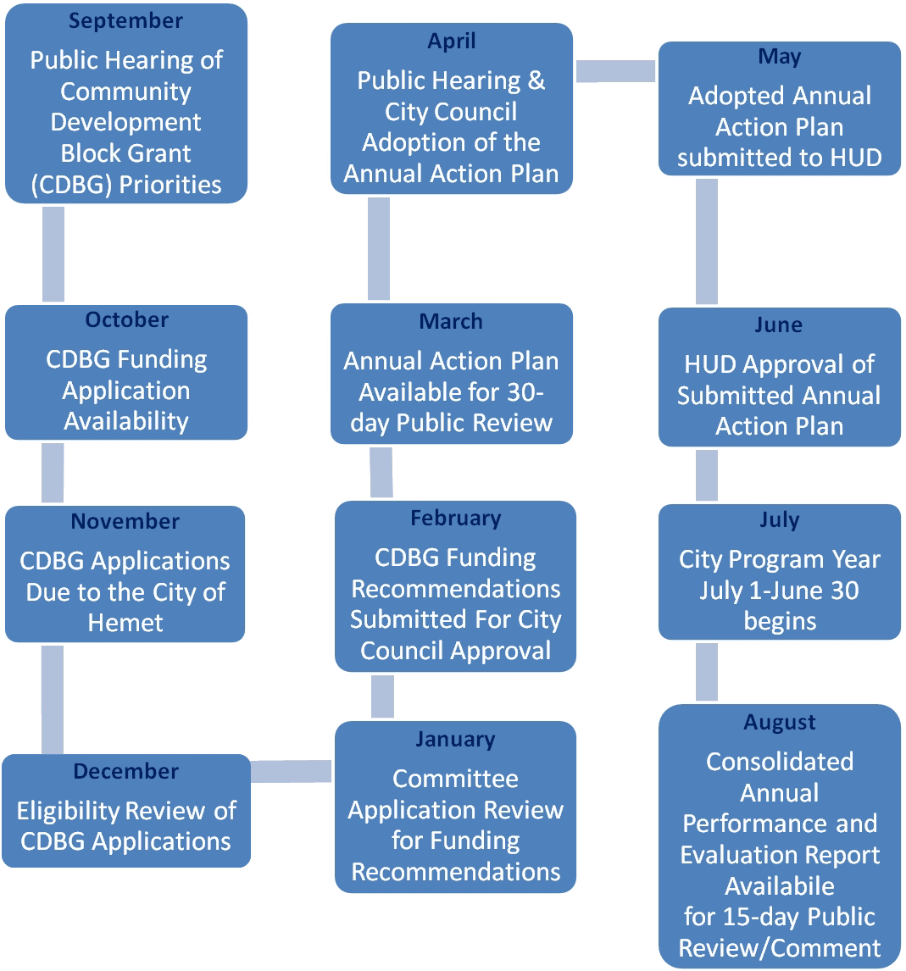

PUBLIC HEARINGS
The City will conduct at least two public hearings at different stages of the Consolidated Plan process and at different times of the program year. Public hearings are required in order to obtain residents’ views and to provide the public with the City’s responses to public comments and questions. Public hearings will be held only after there has been adequate notice as described below in the Public Notice part of this Citizen Participation Plan.

Public hearings will generally be held on the second or fourth Tuesday of the month at 7 p.m. in the Council Chambers located at 450 East Latham, Hemet California, convenient to potential and actual beneficiaries of funding and accessible to people with disabilities. The Council Chambers are located within a block of multiple bus stops, in census tract 043401 which has over 70% low and moderate income residents and where many CDBG activities are or have been located. Reasonable accommodations will be made for persons with disabilities when requests are made at least five working days prior to a hearing. Translators will be provided for non-English speaking persons when requests are made at least five working days prior to a hearing.

In preparing Consolidated Plan documents, careful consideration will be given to all comments and views expressed by the public, whether given as verbal testimony at the public hearing or submitted in writing during the review and comment period. All submitted Consolidated Plan documents will have a section that presents all public comments, City responses, and explains why any comments were not accepted.

Public Hearings during a Disaster
In the event of an unforeseen and unpreventable event that renders in-person public gatherings impossible or inadvisable, such as a natural disaster or pandemic, public hearings may be held as a virtual meeting. Virtual meetings may include webinars, webcasts, telecasts, radio or audio broadcasts, or other virtual communication tools as appropriate for the meeting format. Virtual meetings must be publicly noticed, and in the event traditional noticing tools are unavailable or will not effectively reach the public, alternative public noticing efforts must be made.

In an effort to protect public health and prevent the spread of COVID-19 (Coronavirus) or any infectious disease, the City of Hemet encourages the public to view City Council and Planning Commission meetings online instead of attending in person. Members of the Public who wish to comment on matters before the Council, in lieu of attending in person, may submit comments on or before 2:00 p.m. the day of the meeting. Public Comments shall comply with the adopted Rules of Decorum found in Resolution No. 4545. If you would like to submit a comment, please fill out the form at the following link: Online Request to Speak Form.

The City Council meetings are available virtually and can be viewed live at the following link: hemetca.gov/councilchamberlive. Meetings are live streamed and can be viewed on the cameras using the link above. For additional information or assistance, contact the CDBG Management Analyst at 951-765-3722.

PUBLIC NOTICE
The City of Hemet will provide adequate advance notice of 15 or 30 days, depending on the subject of the notice, at all stages of the Consolidated Plan process to encourage participation by interested parties. To allow for informed comment, notices will provide specific information regarding the subject of the notice including anticipated amount of funding, eligible types of activities, expected benefit to low and moderate income persons, staff contact information, date, time, and location of the event. Notices will be published in the Press Enterprise and the Spanish language, La Prensa as display advertisements in a non-legal section of the newspaper, to increase visibility. In addition notices will be posted on the City’s website www.hemetca.gov.

City of Hemet advance notice for specific documents:
  - Citizen Participation Plan – 15 days
  - Five-Year Consolidated Plan – 30 days
  - Annual Action Plan – 30 days
  - Substantial Amendment – 30 days
  - Consolidated Annual Performance Evaluation Report – 15 days

Public Notice during a Disaster
During events of disaster or emergency where expedited action is required to allow the facilitation of CDBG funds to reach its intended recipients and assist the community, the Public Notice period will be reduced for the specific documents listed above as directed by HUD.

For more information on reduced public notice requirements during a disaster or emergency, please contact the CDBG Management Analyst at 951-765-3722.

WRITTEN PUBLIC COMMENT
It is the policy of the City of Hemet to provide reasonable opportunity, 15 to 30 days, for interested parties to examine the contents of Consolidated Plan documents and submit written comments prior to their finalization. The details for public comment on a specific document will be included in the public notice. City staff will provide a meaningful, written reply within 15 working days, when practicable, and a summary of the comments with City responses will be included with the final document. Generally, documents will be made available for public review at the following locations:

Hemet City Hall
445 East Florida Avenue
Hemet, CA 92543

Hemet Public Library
300 East Latham
Hemet, CA 92543

Public Comment during a Disaster
During events of disaster or emergency where expedited action is required to allow the facilitation of CDBG funds to reach its intended recipients and assist the community, the Public Comment period will be reduced as directed by HUD.

The City of Hemet will make every effort to provide reasonable opportunity for interested parties to examine contents of CDBG documents and submit written comments prior to their finalization. The details for public comment on a specific document will be included in the public notice. Specific documents will be posted on the City’s website www.hemetca.gov. During disaster or emergency events, HUD will allow jurisdictions waivers to shorten the public comment period.

The public notice period for COVID-19 will be no fewer than (5) days and will be noticed in the newspaper with the dates. Any future disaster or emergency will be noticed in the newspaper with specified dates, if needed and as appropriate.

Interested parties wanting to submit a comment may do so by contacting the CDBG Management Analyst, Veronica Allen at 951-765-3722 or vallen@cityofhemet.org.

AMENDMENTS
City of Hemet Consolidated Plan documents will be amended any time there is a change, minor or substantial, in the approved priorities or funds distribution method; the addition of a funded activity not previously approved; or a change in the approved purpose, location, scope, or beneficiaries of an activity. As required by HUD [24 CFR 91.105 (c)] the public will be notified and provided a 30-day opportunity to review and comment, before the public hearing, whenever there is a substantial amendment.

The following will be considered, by the City of Hemet, to be a substantial amendment:
  - The addition, elimination or modification of a priority goal originally described in the Five-Year Consolidated Plan.
  - The elimination of an activity originally described in the Annual Action Plan.
  - The addition of an activity not originally described in the Annual Action Plan.
  - A change in the use of funding from one activity to another described in the Annual Action Plan
  - A change in the purpose, scope, location or beneficiaries of an activity described in the Annual Action Plan.
  - A change in funding by 20 percent or more, whether an increase or decrease, allocated to an activity described in the Annual Action Plan.

This City of Hemet Citizen Participation Plan will be amended only after the public has been notified of the City’s intent to modify it, and only after the public has had a minimum of 15 days to review and comment on the proposed substantial changes.

TECHNICAL ASSISTANCE
City staff will work with organizations and individuals representative of low and moderate income people who are interested in submitting a proposal to obtain funding assistance under the Consolidated Plan. All potential applicants for funding are encouraged to contact City staff for technical assistance before completing a request for funding form. Current contact information:
  - Veronica Allen, Management Analyst – 951-765-3722

ANTI-DISPLACEMENT
The primary objective of the City of Hemet is to avoid or minimize the displacement of individuals as a result of HUD funded activities. Therefore, to the greatest extent possible, the City will:
  - Coordinate code enforcement with rehabilitation and housing assistance programs.
  - Consider the impact of displacement in site selection, during the project planning phase.
  - Phase rehabilitation of multi-family properties to allow tenants to remain during and after rehabilitation.
  - Collaborate with the Housing Authority of Riverside County to utilize existing HUD Section 8 rental voucher programs to house eligible persons who must temporarily relocate during rehabilitation.
  - Assure, whenever possible, that residential occupants have the opportunity to return to their rehabilitated homes.
  - Provide information to displaced individuals on available assistance and relocation benefits.

Prior to approval of any HUD funded activity with the potential for temporary or permanent displacement of individuals, the responsible agency (City or private developer) will provide a written plan of action for comparable replacement low-income housing and assistance to displaced persons, based on the Uniform Relocation Assistance and Real Property Acquisition Policies Act of 1970 (URA), 49 CFR part 24.

COMPLAINT PROCEDURES
The federal government has given the Mayor and City Council sole responsibility and authority to develop and implement the Consolidated Plan and the Annual Action Plan within HUD regulated guidelines. HUD requires thirty-day public review periods for the Consolidated Plan and the Annual Action Plan, while the review period for the Comprehensive Annual Performance Evaluation Report (CAPER) is fifteen days.

Written comments, complaints, concerns or questions addressed to the City of Hemet will receive a meaningful, written reply within 15 working days, when practicable.

Correspondence may be addressed to:

City of Hemet
Finance Department
Attn: Veronica Allen
445 East Florida Ave
Hemet, CA 92543
(951)765-3722
vallen@cityofhemet.org

Persons wishing to contact the Los Angeles Area HUD office may address correspondence to:

Community Planning and Development Division
300 N. Los Angeles Street, Suite 4054
Los Angeles, CA 90012
(213) 894-8000

COLLABORATIVE AGENCIES
The City of Hemet regularly consults with a variety of agencies in the development of Consolidated Plan documents, such as those listed below:
  - Care-A-Van Transit, Inc.
  - Center Against Sexual Assault of Southwest Riverside County (CASA)
  - Valley Community Pantry
  - Fair Housing Council of Riverside County
  - Riverside County Departments – Economic Development Agency, Public Social Services, Mental Health
  - United Way
  - Valley Restart Shelter
  - Valley Wide Recreation and Park District
  - Community Outreach Committee

DEFINITIONS
ANNUAL ACTION PLAN: A one year (July 1 through June 30) planning document, detailing approved funding allocations for specific eligible activities. Submitted to HUD 45 days prior to the beginning of the program year.

CDBG: Community Development Block Grant, a HUD grant which provides for a variety of community development programs that benefit low and moderate income persons.

CAPER: The Consolidated Annual Performance Evaluation Report is prepared at the end of the program year to detail how funds were actually expended and the extent to which these funds were used for activities that benefited low and moderate income people. Submitted to HUD within 90 days of program year end.

FIVE-YEAR CONSOLIDATED PLAN: A five year planning document and application for funding which establishes the City’s priorities and strategies for use of HUD administered funding.

HUD: U.S. Department of Housing and Urban Development, the federal agency which administers and provides guidance for the Consolidated Plan process and use of federal funds such as CDBG.

LOW AND MODERATE INCOME PERSONS: An individual from a household with a total income that does not exceed eighty percent (80%) of the median household income for the area adjusted for family size.
CITY OF HEMET CENSUS TRACT MAP

