Common Questions and Issues
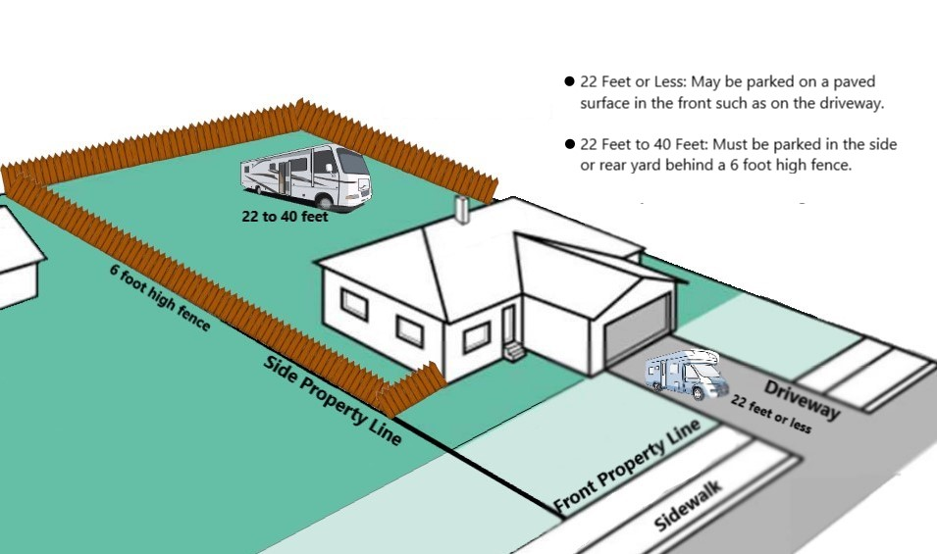
♦ Can I park my recreational vehicle in the driveway?
Currently registered vehicles, including non-motorized vehicles, that measure 22 feet or less in length, may be parked in the front setback area, on a paved surface, either on the driveway or adjacent to the driveway. No portion of the vehicle can overhang or extend onto the street right of way or sidewalk. If the vehicle measures between 22 and 40 feet in length, it may not be parked in the driveway or front area. These longer vehicles may be parked in the side or rear yard setback area when screened by a 6-foot-high solid fencing. The side or rear yard parking area is not required to be paved, but the area shall be maintained free of weeds, junk, trash and debris.
♦ Can I park my recreational vehicle on the street?
A trailer may only be parked on the street as long as it is connected to a vehicle and does not exceed 72 hours. A detached trailer cannot be parked on the street for any length of time. A motorhome or RV may be parked on the street for no more than 72 hours. In all cases the vehicles must adhere to all parking rules and be sure to not block or partially obstruct any driveways, mailboxes, trash carts, fire hydrants, etc.
♦ Can I park my commercial vehicle on the street?
No commercial vehicle may be parked on any residentially zoned- street or property unless it is for the purposes of loading or unloading and trailers shall not be disconnected. Commercial vehicles may only be parked for non-loading/unloading purposes in specifically posted areas

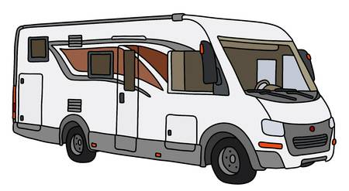
♦ May I display my recreational vehicle as being for sale?
Vehicles may only be displayed for sale on private residential property, on a paved driveway.
♦ My recreational vehicle is no longer operable and I have no means of disposing it, what can I do?
The City of Hemet is able to help with some recreational vehicles or trailers on a case-by-case basis through our inoperable/abandoned vehicle program. Please contact our offices to ask if your recreational vehicle or trailer qualifies for our program.
♦ How can I file a complaint about a recreational vehicle that isn’t mine and I believe to be improperly parked/stored?
Complaints of vehicles on private property may be filed with the Code Compliance Division by mail, telephone, e-mail or through the City of Hemet website. For vehicles parked on the street, please contact the Hemet Police Department at (951) 765-2400. When making a report, please provide the following Information:
• The specific address or location where the vehicle is located. If no address is available, the please provide the nearest cross-streets.
• License plate, description, make and color of the vehicle if known.
• Condition of the vehicle (flat tires, missing engine, transmission, wrecked, dismantled, etc.)
• Your name and phone number so we may contact you if we require any additional details or information

Recreational Vehicle Parking
Do you have a recreational vehicle such as a Motorhome, RV or Trailer and aren’t sure where you can park it?

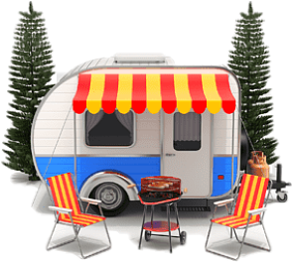
While there are many joys that come from owning larger recreational vehicles, one of the unavoidable difficulties is knowing where you can and cannot park. This brochure will help shed some light on the rules set forth by the Hemet Municipal Code regarding the permitted parking locations for larger vehicles throughout the city. If you have a question regarding recreational vehicle parking that isn’t directly answered in this brochure, please reach out to us and we will be happy to assist you
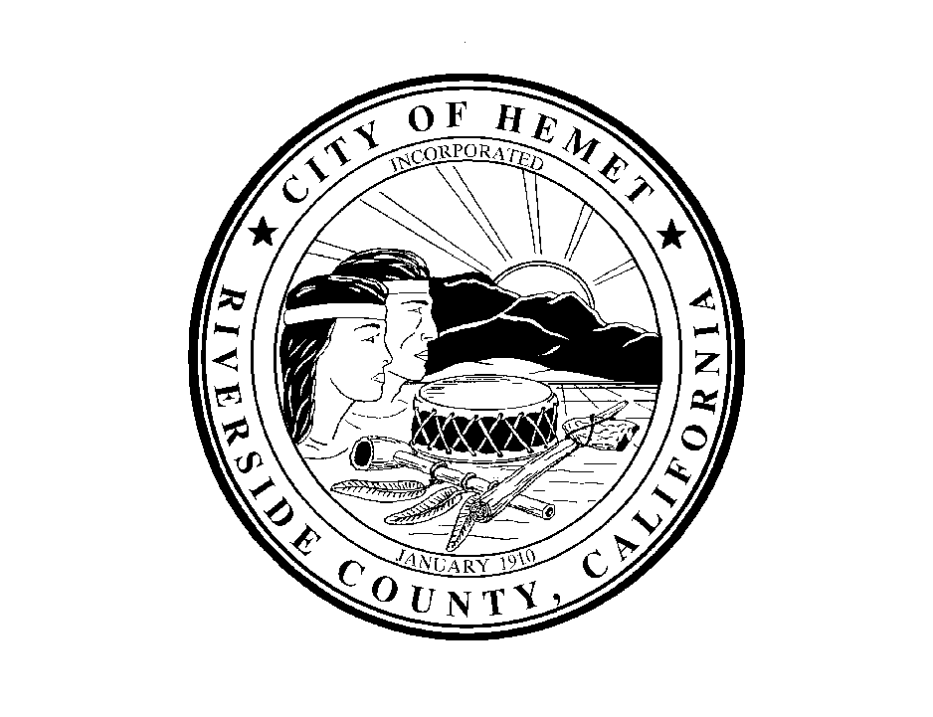Who to Contact
City of Hemet
Code Compliance Division
445 E Florida Ave
Hemet, CA 92543

Tel: (951) 765-2339
Fax: (951) 765-2359
E-mail: codestaff@hemetca.gov
City Website: www.hemetca.gov

City of Hemet
Code Compliance Division
Recreational Vehicle Parking
