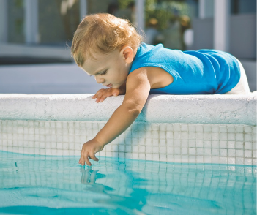
While pools can provide fun and relaxation for many, they also present a potential hazard, especially for young children.
As defined by the California Pool Safety Act 2018 “Swimming pool or pool means any structure intended for swimming or recreational bathing that contains water over 18 inches deep. This includes in-ground and above ground structures and includes, but is not limited to, hot tubs, spas, portable spas, and nonportable wading pools.”
The California Pool Safety Act 2018 now requires that at least two of the following safety features be installed with any pool. For additional details and exact specifications required for each of these items, please visit the City of Hemet’s Website
Do I need a permit?
Yes, when the swimming pool is 24” in depth or greater, a City of Hemet building permit is required, or when electrical is being installed or altered to provide electrical to the swimming pool’s equipment. Extension cords are not permitted to be used.

What are the safety features my pool needs?
Whether you are obtaining a permit for new construction or the remodeling of an existing swimming pool or spa at a private single-family home, the respective swimming pool or spa shall be equipped with at least two of the following seven drowning prevention safety features.
- An “Enclosure” meaning a fence, wall, or other barrier that isolates a swimming pool from access from the home. The enclosure shall meet the following requirements and isolate the swimming pool or spa from the private single-family home
  - Any access gates through the enclosure open away from the swimming pool, and are self-closing with a self-latching device placed no lower than 60 inches above the ground.
  - A minimum enclosure height of 60 inches is required.
  - Any gap between the ground and the bottom of the enclosure should be no more than 2 inches.
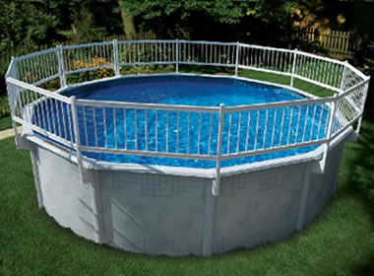
  - Any gaps or voids in the enclosure shall not be more than 4 inches wide.
  - The enclosure must be free of any physical characteristics that could act as a handhold or foothold that could enable a young child to climb over the enclosure.

- An approved safety pool cover that is manually or power-operated and meets all the performance standards of the American Society for Testing Materials (ASTM), in compliance with standard F1346-91.

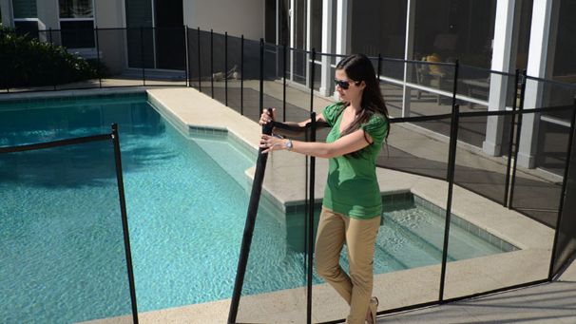
- Removable mesh fencing that meets ASTM Specifications F2286 in conjunction with a gate that is self-closing and self-latching and can accommodate a key-lockable device

- Exit alarms on the private single-family home’s doors that provide direct access to the swimming pool or spa.
  - The Exit alarm may cause either an alarm noise or a verbal warning, such as a repeating notification that “the door to the pool is open”
  - The alarm shall make audible, continuous alarm sounds when any door or window, that permits access from the residence to the pool area

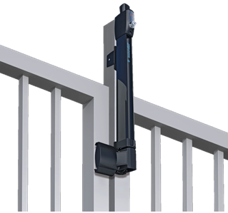
- A self-closing, self-latching device with a release mechanism placed no lower than 54 inches above the floor on the private single-family home’s doors providing direct access to the swimming pool or spa.

- An alarm that, when placed in a
swimming pool or spa, will sound upon detection of accidental or unauthorized entrance into the water.
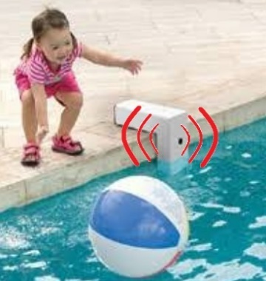
  - The alarm shall meet and be independently certified to the ASTM Standard F2208 “Standard Safety Specification for Residential Pool Alarms,” which includes surface motion, pressure, sonar, laser, and infrared type alarms.
  - A swimming protection alarm feature designed for individual use, including an alarm attached to a child that sounds when the child exceeds a certain distance or becomes submerged in water, is not a qualifying drowning prevention safety feature.

- Other means of protection, if the degree of protection afforded is equal to or great than that afforded by any of the features set forth above and has been independently verified by an approved testing laboratory as meeting standards for those features established by the ASTM or the American Society of Mechanical Engineers (ASME)

These requirements do not apply to any of the following:
- Public swimming pools.
- Hot tubs or spas with locking safety covers that comply with the ASTM Standard F1346
- An apartment complex, or any residential setting other than a single-family home.
- Any facility regulated by the State Department of Social Services even if the facility is also used as the private residence of the operator. Pool safety in those facilities shall be regulated pursuant to regulations adopted therefore by the State Department of Social Services.

If you have further questions, please contact us at:
City of Hemet
445 E Florida Ave
Hemet, CA 92543

Building & Safety Division
Tel: (951) 765-2475
Fax: (951) 765-2481
E-mail: bldgstaff@hemetca.gov

Code Compliance
Tel: (951) 765-2339
Fax: (951) 765-2359
E-mail: Codestaff@hemetca.gov
City Website: www.hemetca.gov

City of Hemet
Building & Safety Division

Pool Safety Requirements


