Is my property in violation?
It may be. Here are common violations that your property may be in violation of.
Overgrown Vegetation
According to Hemet Municipal Code section 30-32(.1)(a)(18)(a-e)
Overgrown vegetation includes, but is not limited to the following:
  - Vegetation likely to harbor, or promote the presence of, rats, vermin and/or insects.
  - Vegetation causing detriment to neighboring properties, or that is out of conformity with neighboring community standards to such an extent as to result in, or contribute to, a diminution of property values, including, but not limited to:

    - Lawns with grass in excess of six inches in height.
    - Hedges, trees, lawns, plants, or other vegetation that are not maintained in a neat, orderly, and healthy manner as a result of lack of adequate mowing, grooming, trimming, pruning, fertilizing, watering, and/or replacement.
  - Vegetation that creates, or tends to create, the existence of a fire hazard.
  - Vegetation that overhangs or grows onto or into any public property, including, but not limited to, any public alley, highway, land, sidewalk, street or other right-of-way, so as to cause an obstruction to any person or vehicle using such public property.

Lack of Landscape
According to Hemet Municipal Code section 30-32(.1)(20):
Lack of landscaping or other approved ground cover in any yard area as otherwise required by the Hemet Zoning Code or other provisions of the City Municipal Code, as well as design guidelines or specific plans adopted by the city council, or so as to otherwise cause or promote the existence of excessive dust or to allow the accumulation of debris.
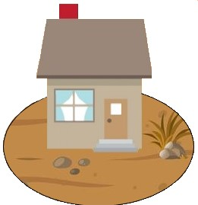
Visible front and side yards shall be mowed, landscaped and otherwise maintained to the satisfaction of the community development director or his or her designee.
Landscape includes, but is not limited to, grass, ground covers, bushes, shrubs, hedges or similar plantings, decorative rock, bark, artificial turf, and sod. Weeds, dirt, gravel, broken concrete, asphalt, decomposed granite, plastic sheeting, mulch, indoor-outdoor carpet or any similar materials are not acceptable landscaping or ground cover. Maintenance of landscaping includes, but is not limited to, regular watering, irrigation, cutting, pruning and mowing of required landscape and removal of all trimmings.

Dead Vegetation
According to Hemet Municipal Code section 30-32(.1)(a)(19)(a-e)
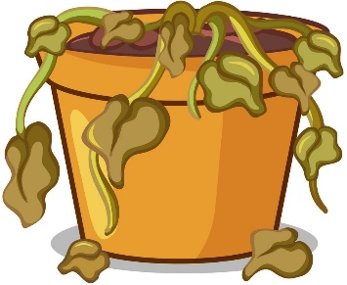
Dead, decayed, diseased or hazardous trees, weeds, ground cover, and other vegetation, or the absence of healthful vegetation, that causes, contributes to, or tends to cause or contribute to, any one of the following conditions or consequences:
- An attractive nuisance
- A fire hazard
- The creation or promotion of dust or soil erosion
- A diminution in property values
- A detriment to public health, safety or welfare.

How to resolve a violation.
- Mow, trim weeds, trees, etc.
- Remove dead vegetation, etc
- Plant or install landscaping that in compliant with planning department.
The City of Hemet encourages the use of drought-friendly groundcovers and plants and has a list of recommended plants available or you can visit www.socalwatersmart.com for available turf-replacement rebates.
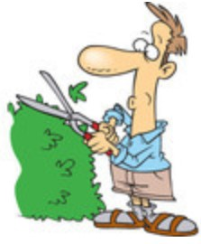

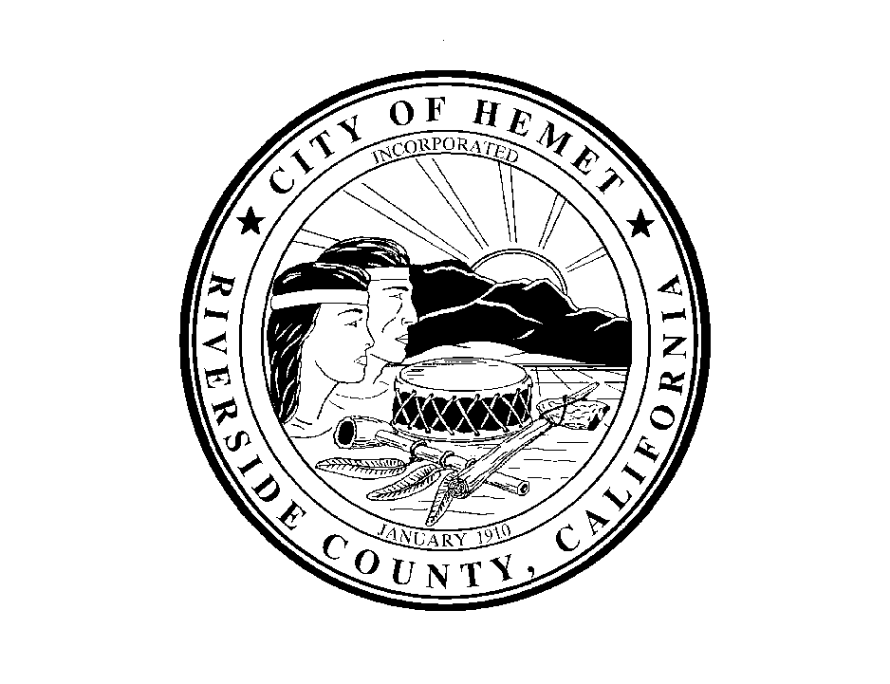

If you have any questions regarding groundcover and landscaping requirements, please contact the City of Hemet Planning Division at (951) 765-2375 or planstaff@hemetca.gov for assistance.

City of Hemet
Code Compliance Division

Landscape Violations

