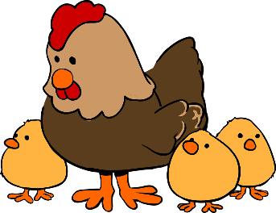

Per Hemet Municipal Code section 90-77 (a-h), chickens may be kept based on the zoning and size of the property, and under specific conditions.

- Residential property that is zoned R-R, R1-40,
R1-20, R1-10 and R1-7.2 must have a minimum
lot size of 7,200 square feet.

- Agricultural property that is zoned A1 or A2
must have a minimum lot size of one acre.

- No chickens are permitted in multi-family zones,
mobile home parks, nor recreational vehicle
parks.

Can I keep chickens?

Why does zoning matter?
Zoning is a big and important part of City planning; it helps keep the city organized and prevents disruptive and potentially hazardous buildings from being too close together such as an elementary school being placed next to a sports bar or a restaurant being located next to a sewage treatment plant. The purpose of zoning is to promote the health, safety, and general welfare of the community. Zoning helps conserve the property values and promotes the most appropriate use of the land.
Assuming your property is zoned for the allowable use of chickens, the following conditions must be met:
Rules of the Roost

Quantity
In permitted residential zones, up to four (4) hens may be kept. NO roosters are permitted in residential zones.
In permitted agricultural zones, up to twelve (12) hens and one (1) rooster may be kept per acre, with a maximum of fifty (50) hens and two (2) roosters.
Conditions
Your Homeowners Association’s CC&Rs may prohibit the keeping of chickens.
Residential properties that are located with a specific planned area, planned unit development overlay district, or planned community development zone are subject to the development standards of that zone.
Chickens must be kept at all times with a suitable pen or coop and must not roam free. Setback requirements do apply.
On agriculturally zoned properties, chicken coops and pens must be kept a minimum of fifty (50) feet away from a residentially zoned property line.
Chicken feed must be stored in a vermin-proof container.
Eggs produced must not be sold commercially.
Keep the chicken’s premises clean and free from offensive odors. Dispose of chicken manure properly.
Chickens must not disturb your neighbors. Complaints regarding odor, cleanliness, treatment, or noise may be investigated by the Code Compliance Officer and/or Animal Control Officer and may result in the issuance of citation(s) if violation(s) are found.
Other Types of Birds

Turkeys, geese, ducks, peacocks, pigeons, emus, ostriches and other domesticated birds have different code requirements not covered under this informational handout.
Potential Animal Abuse?

If you suspect any animals are being mistreated, neglected, abused or kept in unsanitary conditions, please contact the Ramona Humane Society Animal Control Services and provide them the following details
- Address/Location where animal(s) are kept
- Type and approximate number of animal(s) being mistreated
- List your observations of potential animal abuse.

Hours of Operation:
Monday through Thursday
7:30 am to 5:30 pm
Closed on Fridays
Phone: (951) 487-6565
Email: Info@RamonaHumaneSociety.org
Physical Address:
438 S State St.
San Jacinto, CA 92583

Hours of Operation:
Monday through Friday
8:00 am to 5:00 pm

What is My Zone?
City of Hemet
Code Compliance Division

Chicken Keeping Regulations
If your Hemet address has 5 digits, such as 12345 Pine Blvd. please contact Riverside County Planning Department for your property zoning information.
Phone: (951) 955-3200
Email: Planning@Rivco.org

Physical Address: 4080 Lemon Street 12th Floor
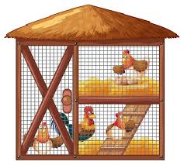
P.O. Box 1409

Riverside, CA 92502-1409

If your Hemet address has 3 or 4 digits, such as 123 Maple St or 1234 Elm Ave. please contact the City of Hemet Planning Division to learn what your property is zoned and if it meets the minimum lot size to permit the keeping of chickens.
Phone: (951) 765-2375
Fax: (951) 765-2359
Email: Planstaff@hemetca.gov
Physical Address:
445 E Florida Avenue
City Hall
Hemet, CA 92543



