FREE
Vehicle Removal
Do you have an old car or pickup truck that won’t run? Did you lose the paperwork for your vehicle or never got around to fixing it and want to just get rid of the thing?

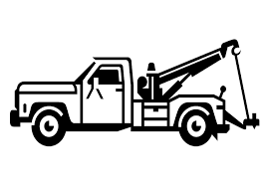
The City of Hemet is here to help. As a public service, the City of Hemet’s Code Compliance Division can arrange to have the vehicle removed from your property absolutely FREE of charge. Thanks to Abandoned Vehicle Abatement Program, the City is able to utilize funds from the State Department of Motor Vehicles to help remove inoperative vehicles with their Vehicle Identification Number (VIN) intact. All you need to do is call us and our staff will take care of all the details. You’ll be helping to do your part to improve your neighborhood and our City.
Who to Contact
City of Hemet
Code Compliance Division
445 E Florida Ave
Hemet, CA 92543

Tel: (951) 765-2339
Fax: (951) 765-2359
E-mail: codestaff@hemetca.gov
City Website: www.hemetca.gov
Common Questions and Issues
♦ What is an inoperative vehicle?
Vehicles that are missing parts such as an engine, transmission, tires, battery, or other parts necessary to operate the vehicle, are considered “inoperative”. In general, the vehicle is not in drivable condition without having to perform special procedures to start and drive the vehicle. Vehicles with body damage that would prevent the vehicle from being driven safely are also considered inoperative or wrecked. Vehicles that are in such condition tend to create an eyesore, can be detrimental to property values, create a health and safety hazard, and can act as an attractive nuisance to the public, specifically to children. Such conditions are considered a public nuisance.
♦ I know my car doesn’t run, but I’m restoring it. I just haven’t had time to work on it.
Hemet Municipal Code Section 30-66 states the following regarding parking or storage of inoperative or dismantled vehicles: It is unlawful and a misdemeanor for any person to abandon, park, store, leave or permit the abandonment, parking, storing or leaving of any licensed or unlicensed vehicle, or parts thereof, which is in an abandoned, wrecked, dismantled or inoperative condition upon any private property or public property, not including highways, within the city, for a period in excess of five days, unless such vehicle, or parts thereof, is completely enclosed within a building in a lawful manner where it is not plainly visible from the street or other public or private property, or unless such vehicle is stored or parked in a lawful manner on private property in connection with the business of a licensed dismantler, a licensed vehicle dealer or a junkyard.
♦ I would put it in my garage, but I don’t have room. Can’t I just put a car cover on it or keep it in the backyard?
No. The law requires that it be stored within an enclosed structure so it is not plainly visible to public or private property
♦ Can I use this program for my RV or Trailer?
The City of Hemet is able to help with some recreational vehicles or trailers on a case-by-case basis. Please contact our offices to ask if your recreational vehicle or trailer qualifies for our program.
♦ There is a vehicle on my property that has been abandoned, can I utilize this program if I do not own the vehicle?
Yes, the City of Hemet will try to contact the registered and legal owners of the vehicle and provide them the opportunity to remove the vehicle, however you as the property owner may fill out the form on this brochure to grant authorization for the City to remove the vehicle from your property. After proper notification, if the vehicle is still present after the 10 days period the vehicle may be towed.
♦ How can I file a complaint about a vehicle that isn’t mine but I know to be inoperable?
Complaints of vehicles on private property may be filed with the Code Compliance Division by mail, telephone, e-mail or through the City of Hemet website. For vehicles parked on the street, please contact the Hemet Police Department at (951) 765-2400. When making a report, please provide the following Information:
• The specific address or location where the vehicle is located. If no address is available, the please provide the nearest cross-streets.
• License plate, description, make and color of the vehicle if known.
• Condition of the vehicle (flat tires, missing engine, transmission, wrecked, dismantled, etc.)
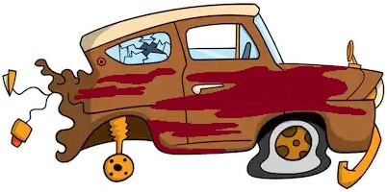
• Your name and phone number so we may contact you if we require any additional details or information.

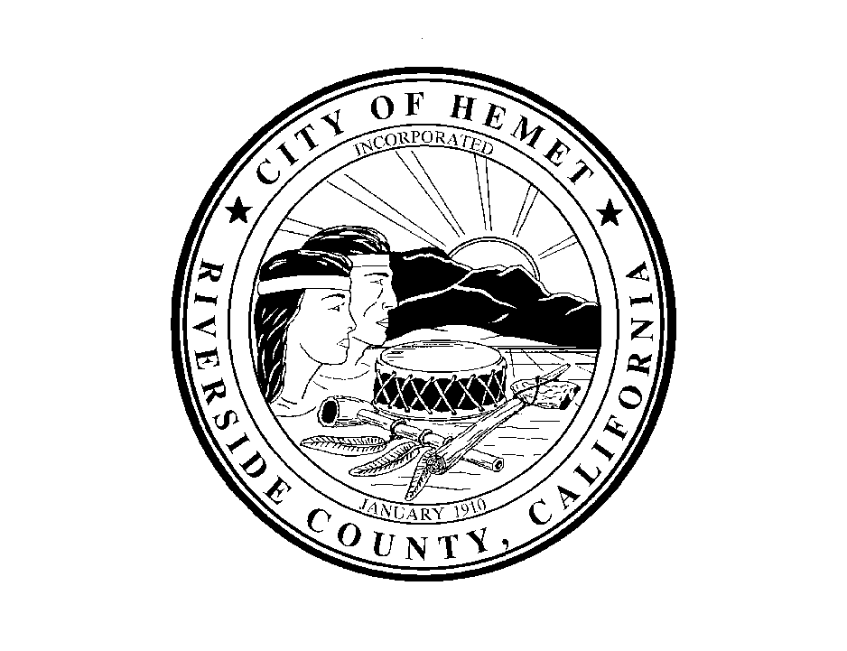

City of Hemet
Code Compliance Division

Vehicle Abatement Program

