 |  |  |  | NEIGHBORHOOD COURTESY NOTICE  Trash Carts Storage: Carts placed in a public  right-of-way for collection shall be placed and  removed from the right-of-way not to exceed 24  hours before and after the collection day. When  storing your carts, no carts shall be visible from the  public right-of-way. HMC Sec 62-11
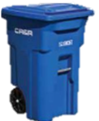
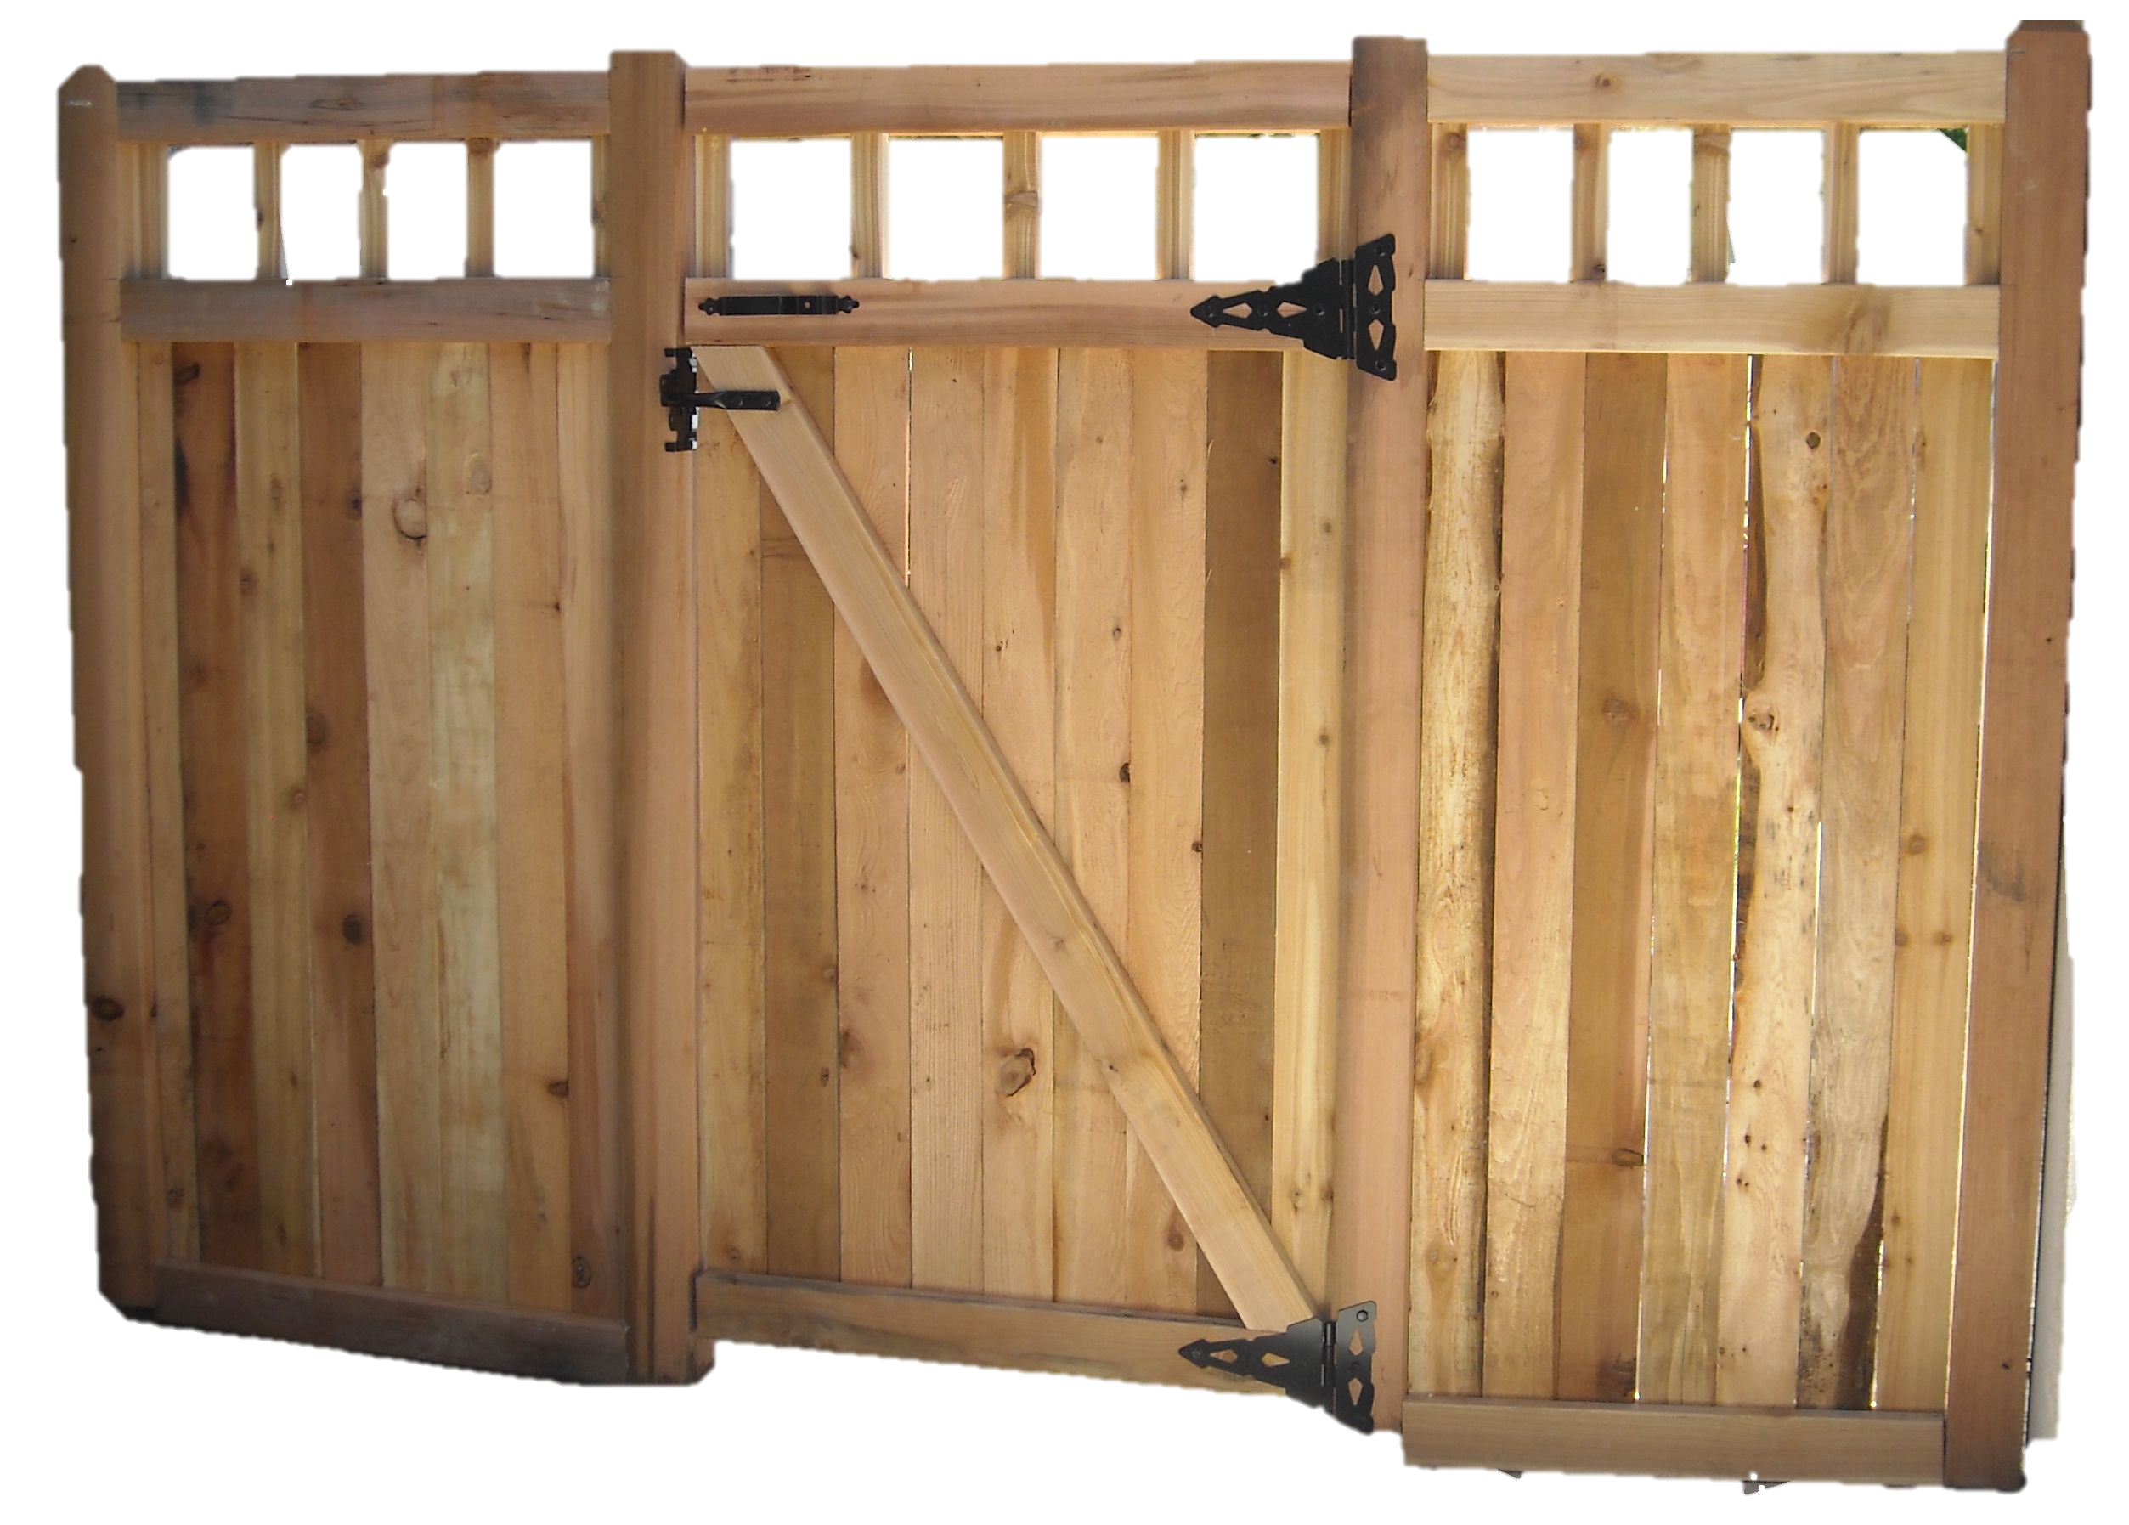

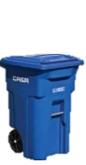

Bulky Items: Items that cannot fit in your automated carts are considered bulky items. Common bulky items include:

Couches - Mattresses - Desk - Chairs - Tables

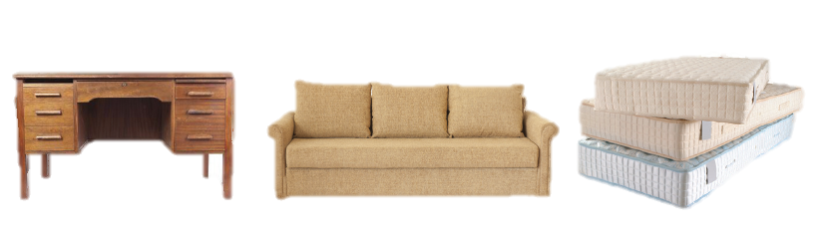
Each residential customer is entitled to two bulky item pickups free of charge per calendar year. Service will include a combination of loose large items not to exceed the equivalent of three cubic yards or two individual large items such as a tv, couch or mattresses. Please contact CR&R to schedule your pick up.

 | 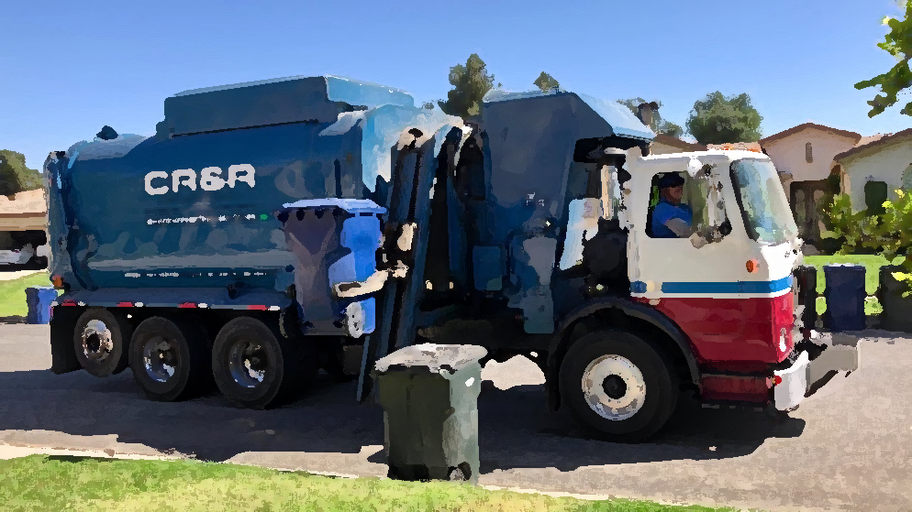
City of Hemet
445 E. Florida Ave.
Hemet, CA. 92543
 |  | (951)765-2339
 |    | Codestaff@hemetca.gov    CR&R Services  (951) 943-1991
Trash carts should be placed at curb side without blocking the public
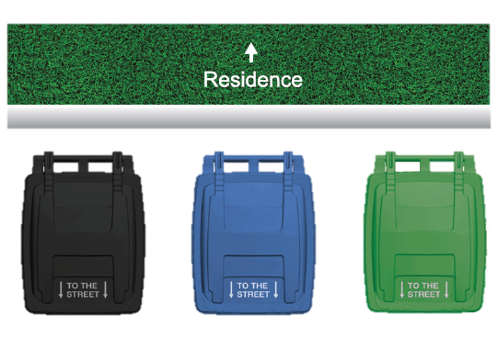
right-of -way. Carts should be placed three feet apart from each other.


